**AP Calculus AB Name: _______________________  
Unit 3 - REVIEW**

|  |  |
| --- | --- |
| **NO CALCULATOR PERMITTED** | |
| 1. |  |
|  |  |
| 2. |  |
|  |  |
| 3. |  |
|  |  |
| 4. |  |
| 5. |  |
|  |  |
| 6. |  |
|  |  |
| 7. | The is…  A. sin *x* B. *x* C.  D. cot *x* |
|  |  |
| 8. | The has a value of …  A. 0 B. 1 C.  D. −1 |
| 9. | The equation of the normal line to the graph of *y* = *e*2*x* when is…  A.  B.  C. *y* = 2*x* + 1  D. |
|  |  |
| 10. | If , then  is …  A. 0  B.  C.  D. |
|  |  |
| 11. | For what value(s) of *k* does the graph of *g*(*x*) = *ke*2*x* + 3*x* have a normal line whose slope iswhen *x* = 1?  A. *e* B.  C.  D. |
|  |  |
| 12. | If , then  =  A. 2 B. 4 C.  D. 8 |
| **CALCULATOR PERMITTED** | |
| 13. |  |
|  |  |
| 14. | Given that *f*(*x*) = *x*2*ex*, what is an approximate value of *f*(1.1) if you use the equation of the tangent line to the graph of *f* at *x* = 1?  A. 3.534  B. 3.635  C. 7.055  D. 8.155 |
|  |  |
| 15. | Let *f* be the function given byand let *g* be the function given by. At what  value of *x* do the graphs of *f* and *g* have parallel tangents?  A. −0.701 B. −0.567 C. −0.391 D. −0.302 |
|  |  |
| 16. | Which of the following is an equation of the line tangent to the graph of at the point where.  A. *y* = 8*x* – 5 B. *y* = *x* + 7 C. *y* = *x* + 0.763 D. *y* = *x* – 0.122 |

**FREE RESPONSE #1 (No Calculator)**

Consider the piece-wise defined function below to answer the questions that follow.



a. If *a* = –3 and *b* = 4, will *f*(*x*) be continuous at *x* = 2? Justify your answer.

b. If *a* = –3 and *b* = 4, will *f*(*x*) be differentiable at *x* = 2? Justify your answer.

c. For what value(s) of *a* and *b* will *f*(*x*) be both continuous and differentiable at *x* = 2? Show your work.

**FREE RESPONSE #2 (Calculator Permitted)**

A rodeo performer spins a lasso in a circle perpendicular to the ground. The height from the ground of the knot, measured in units of feet, in the lasso is modeled by the function

,

where *t* is the time measured in seconds after the lasso begins to spin.

a. Find the value of *H*(0.75). Using correct units, explain what this value represents in the context of this problem.

b. Find the value of . Using correct units, explain what this value represents in the

context of this problem.

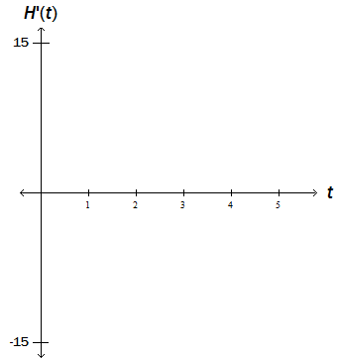c. Find and sketch its graph on the axes to the right for the interval 0 < *t* < 5 seconds.

d. During the first five seconds of the performer spinning the lasso, how many times is the lasso

at its maximum height? Give a reason for your answer based on the graph of .

e. What is the height of the lasso the first time it is at its minimum height on the interval

0 < *t* < 5 seconds? Justify your answer and show your work.